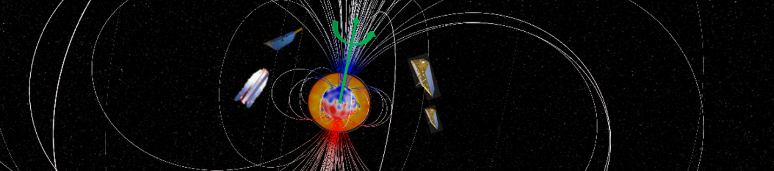
Doctoral position: Extracting the common signal of the deep Earth’s interior from the magnetic and gravity fields
Location: Université de la Rochelle, France
Starting date: 09/2021
Supervisors: Olivier de Viron, Mioara Mandea
Contact: olivier.de_viron@univ-lr.fr, mioara.mandea@cnes.fr
Keywords: space-time series analysis, mathematical methods used in geophysics and space physics, geomagnetic and gravity field variations
Summary:
The position is funded by the ERC Synergy grant ‘GRACEFUL’ led by Véronique Dehant (Brussels), Mioara Mandea (Paris) and Anny Cazenave (Toulouse). The Ph.D Student will work more specifically with Mioara Mandea (CNES Paris) and will benefit from a CNES doctoral contract. He/she will work in the Departement sciences de la Terre (Université de la Rochelle) where he/she will be supervised by Olivier de Viron.
The core flows (including jerks and waves) produce a signature in both magnetic and gravity variations at decadal timescale. The researcher will analyse time series of magnetic and gravity fields at the Virtual Observatory positions (concept proposed by Mandea and Olsen, 2006) from which seasonal signals and trends are removed, as both are non-random signals and are associated with many sources of forcing in the Earth’s system. Without this removal, similarities might be induced between the two fields, though associated with unrelated causes. These series of magnetic and gravity fields are produced via two different working-packages in the frame of the GRACEFUL project. The purpose of the post-doctoral is to develop join analyses over the two fields, to study (tele)-connections between the two fields, using space-time methods such as Singular Spectrum Analysis, Dynamic Mode Decomposition, Empirical Orthogonal Teleconnections. Here, it is important to go beyond a point-by-point correlation study between the two series and to search for zones over the Earth with a significant correlation. Using method of data reduction, such as PCA, to isolate the major features of both fields, and retrieve the dominant time structure of the variability for each field, we will used further methods to study the links between the signal from both fields, in order to retrieve their connections and assess their significance.
First, just as there are no reasons why the magnetic and gravitational signatures should be localized at the same position on Earth, magnetic and gravitational signatures could be unsynchronized. Some methods have been proposed to study unsynchronized correlations and causalities, such as Singular Spectrum Analysis (Ghil et al., 2002 and references therein); those can be applied to this problem. The structure of the common time variability is also worth investigating, as it can bring insight on the physical process. Investigating the raw magnetic data and mascon gravity data (i.e. a localized time variable gravitational anomaly) might allow a better localization of the phenomena, resulting in a better description of the common variability. Recent stochastic methods, such as the convergent cross mapping, proposed to investigate causality in complex system, can be applied in order to go deeper in the causality mechanisms.
The main aim of the thesis project is to investigate novel methods and to apply them to this specific study.
The candidate should have a background in geophysics, with a strong interest and ability for numerical and statistical methods or in physics, applied mathematics, numerical sciences, with an interest in geophysics. He/she will work jointly with M. Mandea at CNES and members of the team of Departement sciences de la Terre, including possible collaborations with colleagues from ISTERRE Grenoble et EOST Strasbourg.
REFERENCES
Mandea, M. and Olsen, N., A new approach to directly determine the secular variation from magnetic satellite observations. Geophysical research letters, 33(15), 2006.

Ghil, M., R. M. Allen, M. D. Dettinger, K. Ide, D. Kondrashov, et al., Advanced spectral methods for climatic time series., Rev. Geophys. 40(1), 3.1-3.41, 2002.

WE ARE LOOKING FOR

The ideal candidate with a master in statistics, mathematics, geodesy, geophysics, or computer sciences, and combines many of the following characteristics:
- Scientific curiosity
- Strong interest in the field of space research
- Application of methods of mathematical physics
- Knowledge of basic mathematical methods for the application in geophysical problems
- Creative and pragmatic problem-solving approach
- Experience in numerical modelling
- Capability to work in English.

HOW TO APPLY
Send your CV (including grades) with a cover letter and if possible two or three support letters (all in PDF format) by June 1st, 2021 to mioara.mandea@cnes.fr, olivier.de_viron@univ-lr.fr

